What’s a‘Foul’ in Kachemak Bay!
Current and Future Plate Watch Monitors
please join the Smithsonian for an all-day workshop
What to expect
- review the goals and protocols for monitoring non-native marine invertebrates through the Plate Watch Program
- participate in hands on learning with the targeted taxonomic groups of non-natives
- learn the basics of environmental DNA (eDNA)
- participate in an eDNA pilot for community scientists in Alaska
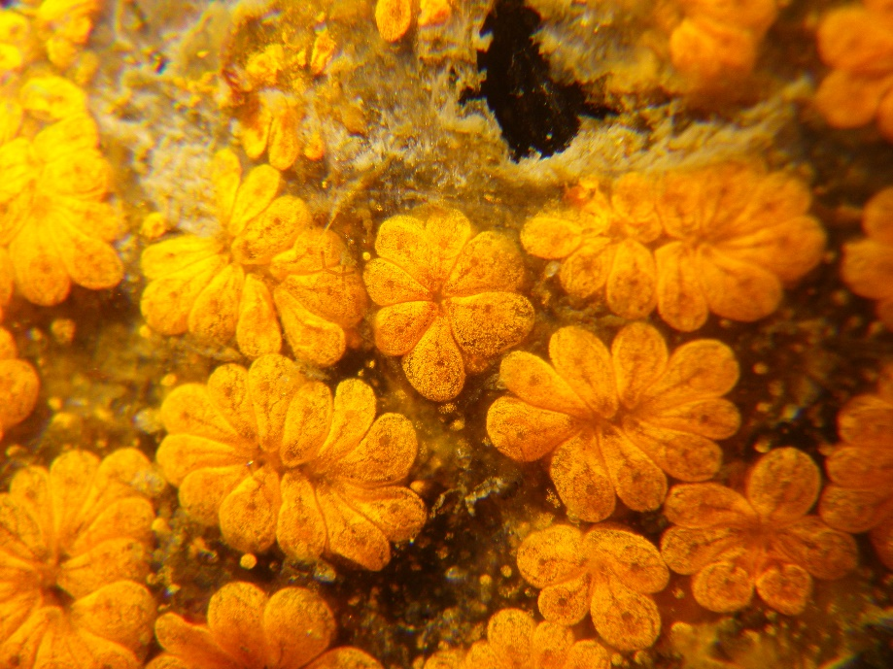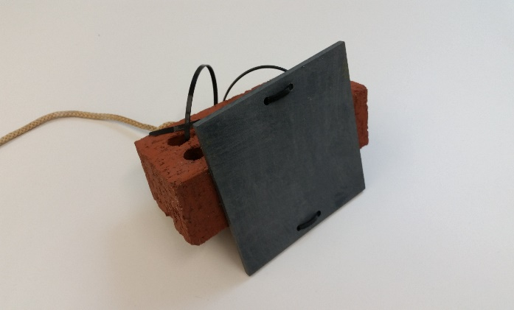
Aug 22, 9-4PM
Kachemak Bay National Estuarine Research Reserve
2181 Kachemak Dr, Homer, AK
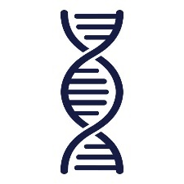
Snacks and Lunch provided 