What’s more fun than a net full of fish? A Bioblitz!
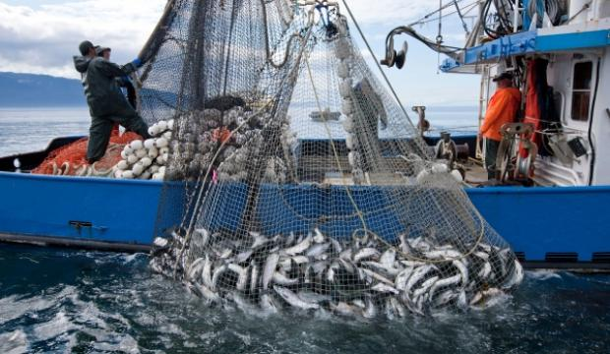
Sept 8, 2018

Burma Road Chapel
930-3PM

From the Juneau Empire 27-07-2015

Join us for a search for all that crawls, squirts, and sits on the bottom of the ocean in the first
Unalaska Marine Invertebrate Bioblitz!
You will:
- Learn about the animals you might see in the harbor
- Help scientists collect specimens for a global genetic database
- Look at critters through a microscope
- Hear about cutting edge research by the Smithsonian and Alaska Sea Grant
Lunch will be served (No charge to participants!!!)
Don’t miss the Prebioblitz Talk Wednesday, Sept 5, 7PM !!!
Unalaska Library Conference Room

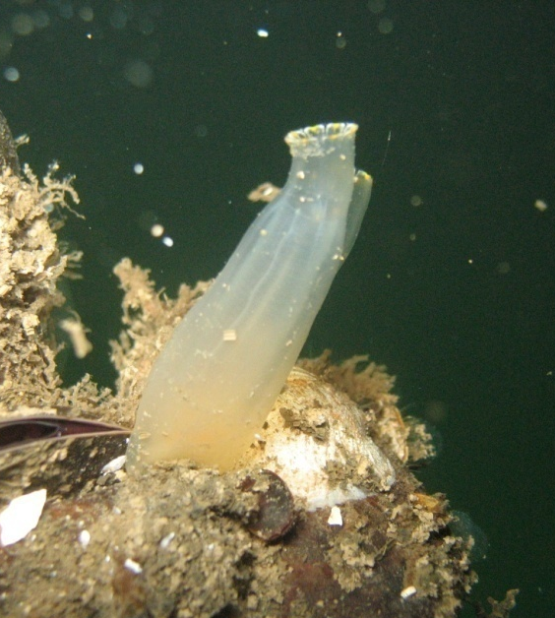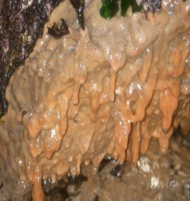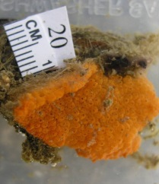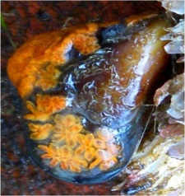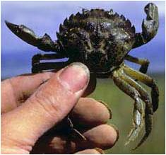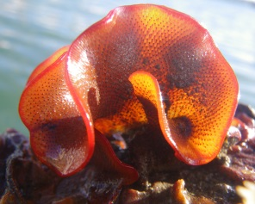
Photo Credits from left to right: Jana Nicols, Marnie Chapman, Gary Freitag, Heather Meuret-Woody, NERR Kachemak staff, Melissa Frey
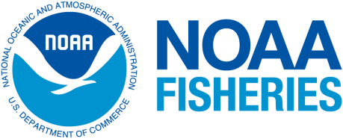
Questions? Contact Melissa Good at 581 1876 or melissa.good@alaska.edu

